**Prodigy’s Tale**

**SEASON: 1**

**CHAPTER 3: “Caravan and Rejection”**

The Forward Base personnel had a puzzled expression, and the other council members appeared to be skeptical. The Commander-in-Chief irritably pointed at the Secretary and told them, "This is Isaac, alongside with those greenhorns, the council gives a new and secret mission," the Forward Base personnel finally got it, and some council members frowned from hearing the secret mission, then the Commander-in-Chief pointed at Javier and continued, "and here our little fella was the Council’s chosen”, now everyone in the meeting nods and had nothing to say, seemingly satisfied, Isaac clapped his hand to catch everyone's attention and gave them the hazy idea of obtaining a good term with the king of elves under the guise of requiring help from the desert monster that was becoming stronger. And pointed at Javier and told them, “He’s going to be our delegation for the mission”.

Once a while, the Forward base can travel to a nearby town to do business such as trading, purchasing, and selling products, however they cannot sell items containing technology because the Empire forbids it. Therefore they align it with the weekly caravan. Javier has three days before departing; in the meanwhile, he fights the horde and studies rudimentary elf language. The appointed time had arrived they can’t carry a heavy guns for it was forbidden; he was only carrying a small pistol and a sword for his safety. The caravan travelled with ease as desert slowly turning to a beautiful view full of vibrant and lush vegetation and it was quite new to Javier, a rich bright world, this was a genuine fantasy world.

The Ehserin town *(See figure 1)* was small but crowded with guests, most of whom were elves, with only a few human soldiers visible. Javier with a few people from the council and HQ (2 from council and 3 from the HQ) headed to the town hall to request assistance in entering the Empire. When they enter the Town Hall, they are greeted by the receptionist. They request an audience with the mayor, but they are denied and must wait for a while. Without a choice, they back away to wait. While waiting, Javier and his companions take a tour about town to enable Javier become acquainted with the area for future reference. It’s already afternoon when they get back to the town hall and this time, they meet the Mayor. They asked the mayor if they could help them get an audience with the Emperor because the desert monster was getting stronger. The Mayor told them that it was a serious problem, but the Mayor completely rejected them by telling them that meeting the Emperor was impossible even for him, but he said they could meet the Crowned Prince.

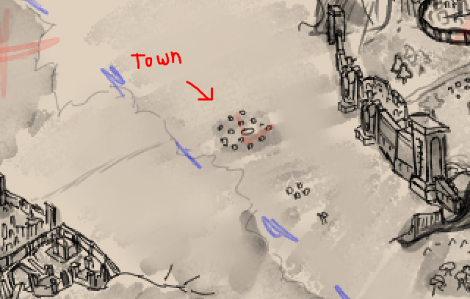

*Figure 1: The Ehserin Town*

Carrying the recommendation letter they travel into the Empire Gates. At the Empire’s gate they are blocked by the Gate Keepers and asked them what is their purpose in carrying their filth to the Empire. Having learning basic Elfish language he understand the blatant provocation, Javier can’t hide his displeasure about it the guard notice Javier’s displeasure, he smirks and provoke Javier even further. As the situation deteriorated, one of the council members passed the letter to the other guard and informed them that they had received a recommendation letter from the Mayor of Ehserin. Hearing the commotion the guard leader approach them and take the letter, He silently read it before then passing it to a messenger and told the delegation that it's impossible to meet the Crown Prince for there are absolute rule that they are not qualified to enter the sacred ground of the Empire. The delegation's attitude deteriorates due to the prejudice, but they are unable to dispute because of the first contract. When the delegation was about to flee in defeat, a trumpet sounded, signalling the arrival of a royalty, and all of the elves fell on their knees, the delegation rushed to get on their knees, when the gate opened. A carriage bearing a crescent of the world tree emerges, the crown prince's carriage stops, and the crown prince comes out.

The crown prince asks the leader of the keepers on what is happening when the messenger quickly headed there and delivers the letter to the crown prince. Upon reading the letter the crown prince snickers and told the delegation that it was unfortunate that he can’t decide for the matter, it’s not their problem in how the humans was getting difficulty fending some lowly creatures. Javier really can’t hide his displeasure as he emits hostility to the crown prince, where the keepers and the crown prince knight reacts and quickly move to behead Javier. Javier quickly fend of the assailant and was about to draw his gun, the crown prince shouted stop. He was fascinated in how Javier fend off an elite knight quick slash, so he propose that if Javier defeat him in a sword fight he would consider helping them about the reinforcement request.

Javier was completely devastated by the crown prince. The crown prince belittles the human capacity but satisfied by Javier’s tenacity so he told him if he wants the reinforcement, he needs to gather approval from the Northern Elves.

**End of Chapter 3**